Project Notes:

- Scaling and Normalization are two important preprocessing techniques used to transform data, ensuring that machine learning algorithms work more effectively. They are particularly important when the features in a dataset have different ranges or units.

Numeric columns are processed with statistical techniques (e.g., scaling, normalization).
Categorical columns require encoding methods like:
Label Encoding (for ordinal or simple categories).
One-Hot Encoding (for nominal categories with no order).

Scaling refers to adjusting the range of your numeric features to a specific scale, usually to have values between a certain range or to be standardized.
Normalization is a specific type of scaling that generally refers to transforming data into a fixed range (usually [0, 1]). This term is often used interchangeably with Min-Max scaling.

Encoding in categorical columns is the process of converting categorical data (data that represents categories or labels) into a numerical format that can be understood and processed by machine learning algorithms

Machine Learning Models Expect Numbers:
- Many algorithms, such as linear regression, support vector machines, and tree-based models, expect numerical inputs. Encoding converts textual or categorical data into numeric representations.
Improves Model Performance:
- Proper encoding ensures the algorithm can process the data accurately, leading to better predictions.
Handles Complexity in Relationships:
- Encoding helps preserve relationships or hierarchies within categorical data when necessary.

Label Encoding
Converts each category into a unique integer value.
Categories: ['Red', 'Green', 'Blue'] Encoded: [0, 1, 2]

Hot Encoding
Converts each category into a separate binary column (0 or 1).
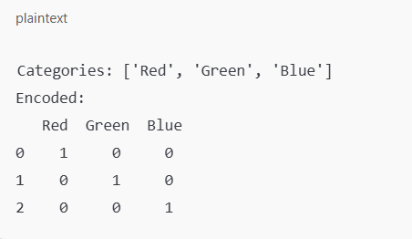

Handle Missing Values in Numeric Columns
Many machine learning algorithms cannot handle missing values. Filling missing numeric values with the mean is a common practice as it preserves the column's overall distribution.

Handle Missing Values in Categorical Columns
Replaces missing values in categorical columns with the most frequent value (mode).

Why Use This Preprocessing Pipeline?
- Improves Data Quality:
  - Handles missing values, ensuring the dataset is complete and consistent.
- Prepares Data for Machine Learning:
  - Machine learning algorithms cannot handle categorical data or missing values. The pipeline resolves these issues.
- Enhances Model Performance:
  - Scaling numeric data ensures that features contribute equally to the model, preventing dominance by features with larger magnitudes.
- Automates Repetitive Tasks:
  - Separating numeric and categorical preprocessing allows systematic handling of different types of data.

When to Use?
- When working with a raw dataset that contains missing values, categorical data, and features with different ranges.
- Before training machine learning models to ensure data is clean, complete, and properly formatted.

scale — scikit-learn 1.5.2 documentation -> Scaling
Normalizer — scikit-learn 1.5.2 documentation -> normalizer
LabelEncoder — scikit-learn 1.5.2 documentation -> LabelEncoder

Standardization Vs Normalization- Feature Scaling – video explain
Data Encoding | One Hot Encoding Encoding | Data Preprocessing | Machine Learning | Data Magic
Whole video series

